Please fill out this Word document and return to Bikes for Tykes to receive consideration for a volunteer position. You may mail this completed form to our mailing address, attach it to an email to info@bikesfor tykes.org, or drop it by our office.
Bikes for Tykes, Inc is a 501(c)(3) organization working in the greater Collier County area to provide bicycles and bicycle maintenance to underprivileged children and adults. We invite volunteers of any race or creed to interact with clients and other volunteers at our site and by providing various services at client sites.
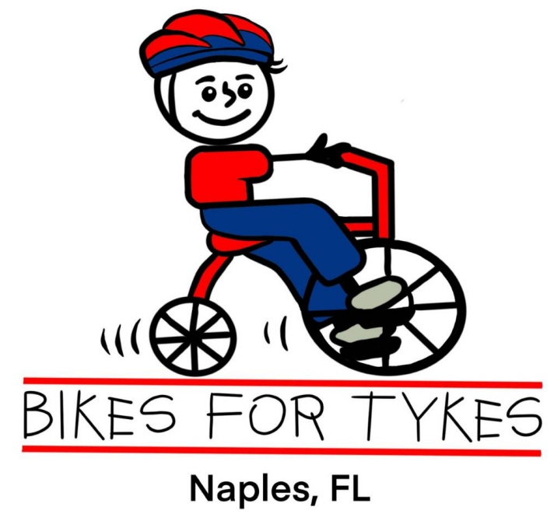
After we receive your application, we will contact you and arrange for an interview in person or by phone with our volunteer coordinator. All information on this form will be kept confidential and will help us find the best volunteer projects for you.
Please be advised that, since we work with a vulnerable population, we may require a background check.

First Name:
Last Name:
Street Address:
City:
State: Zip:
Cell Phone: Email:
Date of Birth:

What skills, special interests or experience would like us to consider when placing you into an appropriate position? (e.g., mechanical, financial, grant writing, event management).
-

Here are some of the volunteer positions we offer. Please check the ones you would consider.
☐ Bicycle Mechanics- perform basic rebuilding and new bike assembly.

☐ Project Management – lead bike builds, elementary school programs, celebratory events, promotional activity.
☐ Fundraising - grant research and/or writing, donor data base management, donor liaison activity
☐ Communications – manage public relations, social media, email campaigns, software selection.
☐ Website - WordPress design, updates, and maintenance.
☐ Transportation to support events – operate a pickup truck with hitch.
☐ Teaching – bike skills and safety activity to children, promote BFT mission
☐ Volunteer recruiting – design and manage events.
☐ Legal - expertise with nonprofit operations
☐ Accounting – oversee or manage accounting functions
☐ Board – apply for a board position
☐ Fill in the experience that you would share:
_______________________________________________________________________________
What days are you usually available? Mon: ☐ Tues:☐ Wed: ☐ Thurs: ☐ Fri: ☐ Sat: ☐
How many hours are you available per week?
Do you prefer: Morning ☐ Afternoon ☐ Either ☐
Please describe any physical limitations:

Emergency contact:
Name:
Phone: Relationship:
Liability Release:
As a volunteer of Bikes for Tykes, I agree to abide by all policies and procedures as spelled out in the volunteer handbook. I understand that I volunteer at my own risk and neither the organization nor its employees assume any liability for any accidental injury or health problem arising from volunteer work I perform for the organization. I agree that all work I do is on a volunteer basis and I am not eligible to receive any monetary payment or reward.
Signature: Date:

